THE
ROYAL LODGE

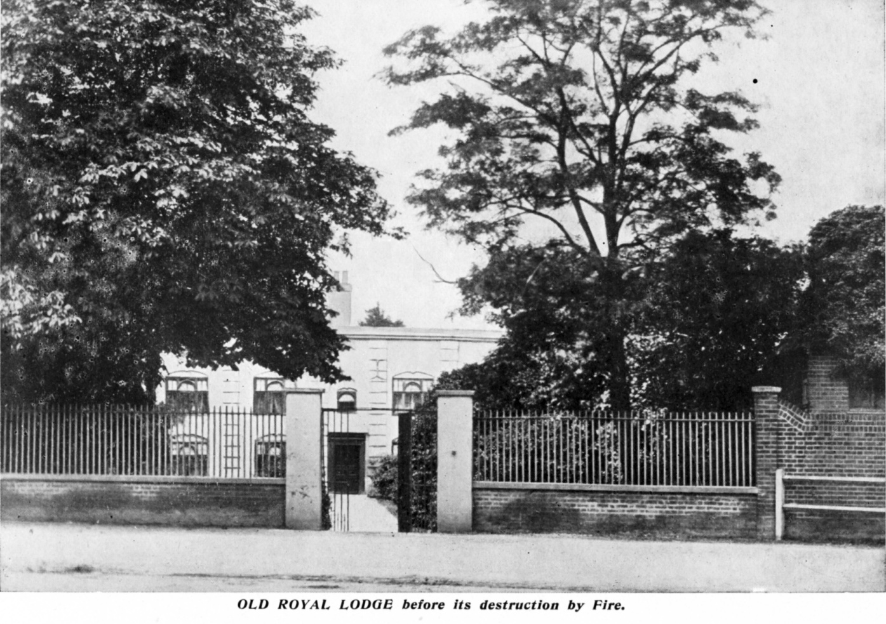

FREDERICK TEMPLE

Leyton & Leytonstone Historical Society
The Royal Lodge
by Frederick Temple

Unpublished manuscript printed for the first time in 2010 with the very kind permission of the author’s grandson, John Temple,

with a preface by David Ian Chapman and an appendix by David Boote,

by
Leyton & Leytonstone Historical Society
27 The Croft
Friday Hill
London
E4 6EZ

Website : www.leytonhistorysociety.org.uk

Preface

The manuscript from which this book has been printed was discovered amongst Frederick Temple’s (1881 – 1972) immense amount of information gathered together on the history of the ancient parish of Leyton. Leyton & Leytonstone Historical Society has embarked on a programme of reprinting some of his completed histories, of which this is the latest.
The text is substantially as written down by Frederick Temple but with the addition of footnotes where these would be helpful. Errors have been silently corrected.
William Hammock helped to foster the locally held belief that the Royal Lodge’s name stemmed from its historical connections. Queen Elizabeth is thought to have used the house as a hunting lodge when chasing sport close by in the Great Forest of Waltham. Another legend surrounds the story of the house being used by King Charles II and from where he conducted clandestine assignations with Nell Gwynne using a secret tunnel leading to The Cedars opposite. Whilst those romantics amongst us would like to believe in these tales there is no documentary evidence to support such meetings, although during restoration following the fire of 1878 one of the daughters of the then owner, Henry Clayton, mentions that a number of coins from the reign of Charles I were found. A further discovery of some old shoe buckles caused Henry Clayton to half jokingly remark that they may have been owned by our Nell.
What is known is that Charles II did visit Leyton where he was entertained by Sir William Hicks at Ruckholt House, after a day’s hunting. And the fact remains that Leyton was only five miles from the gates of London, yet secluded enough to allow discreet liaisons.
A short note on dating of births, marriages and deaths : many of the dates given have been taken from Ancestry.com. With the introduction of national registration, since 1837 these will almost certainly be actual dates. Prior to 1837 and where based on Parish Records, apart from marriages, births will almost certainly be baptismal records and deaths, burial records.

David Ian Chapman
June 2010

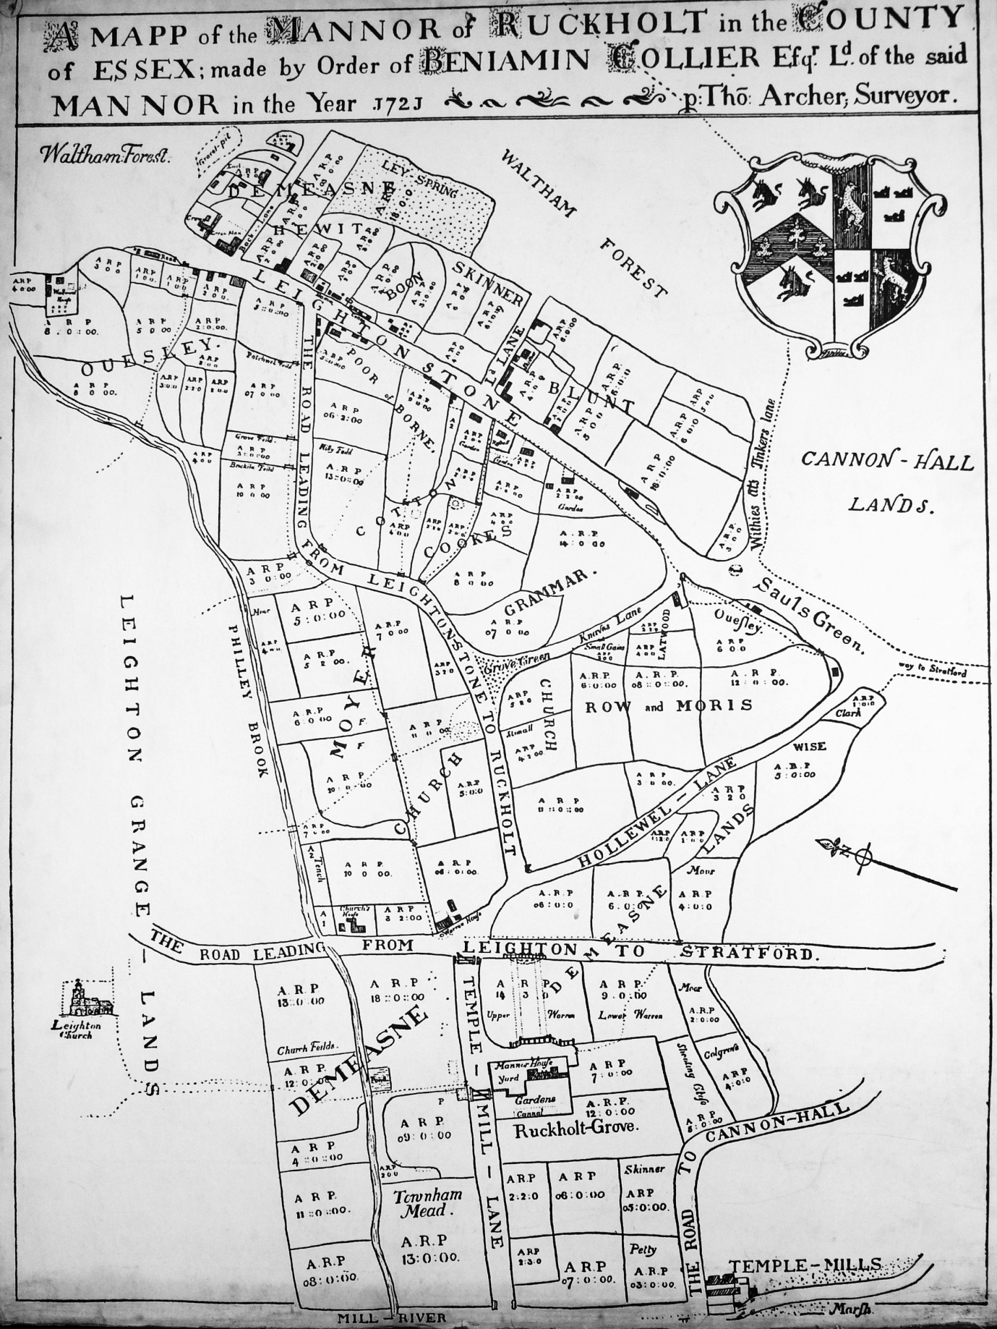
Map of Ruckholt Manor by Thomas Archer, 1721
The Royal Lodge is situated opposite “Ld Lane” (Lord Lane)

ROYAL LODGE
by
FREDERICK TEMPLE

W G Hammock, in his book, Leytonstone and its History (1904), has written an account of this house (pp 20-21). Some of this is certainly to be relied on but some is based merely on surmise and must be discredited. Since this account was written information, chiefly contained in the Manor Rolls of Ruckholt Manor, has recently become available which has thrown more light on the history of the house and so enabled a more reliable account of it to be made.
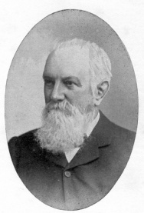
The house which stood on the west side of High Road, Leytonstone, opposite the ancient Davis Lane, is shown in an illustration in the fore-mentioned book as it was before suffering great damage by fire in 1878, after which it was rebuilt by its owner Mr Clayton and later came into the possession of Mr Hammock. As time passed, however, in common with many other old properties in the neighbourhood, it could find nobody able to maintain it in fit condition for residence and being unoccupied became derelict by the middle 1920’s and was demolished in 1932. On its site was built the Rex Cinema with part of the extensive grounds being converted into a large car-park for the use of its patrons. A range of old stable buildings which lay on the south side had previously been pulled down to make way for the construction of part of the Tottenham and Forest Gate Railway (later known as The Midland). This would be about 1890.
The Manor Rolls tell us that at Court of 11 April 1583, it was reported that a John Thatcher, goldsmith, had died, seized of a tenement with cartilage, garden, 5 acres of land, 1 rood of meadow in Townham Mead, and 2 acres of land at Grove Green called Andrews. His heirs were his wife, Martha, who received one-third as dower for life, and the remainder to his three young daughters Thomasina, Anne and Elizabeth.
1
John Thatcher is mentioned in the very first Roll of 1567 and his copyhold property most probably goes back very many years.
By 1593 the Court found that the mother and Thomasina were dead and so Anne (now 15) and Elizabeth (now 14) were admitted as Copyhold tenants of all, this through their guardian, Richard Barton.
By 3 April 1598 Elizabeth, now wife of William Death, and her sister Anne surrendered at Manor Court their property called Andrews to Thomas Stone (son of William Stone), cloth worker of London. No mention then of the one rood of meadow is made.
At Court held 9 June 1614 it was reported that Thomas Stone had surrendered shortly before this copyhold (together with others he held) to Robert Garsett, gent of London, to which he was duly admitted and held until 25 June 1632 when he mortgaged it to John Bancroft for £100. At the Court of 15 October 1635 the jurors found that the £100 had not been repaid whereupon John Bancroft paid homage and was admitted to Andrews. It is evident that Robert Garsett had regained his interest in Andrews as although not stated on the Rolls he was enabled to mortgage it to Isaac Jones and later this mortgage was declared “void” at the Court of 7 September 1636 as Jones had been repaid. The Roll of this date contains a very important piece of evidence as it states that the occupying tenant was the “Earl of Lindsay or his assigns”. This person was Robert Bertie, 12th Lord Willoughby, created Earl of Lindsay by Charles I in 1626, Lord Great Chamberlain and General of the King’s forces who was killed at the Battle of Edgehill in 1642. He was Warden of the Forest of Waltham and the settlement of debts pertaining to its upkeep and maintenance was in his hands. It is certainly due to his tenancy that the house received its name of Royal Lodge. It is quite likely that his royal master might have stayed here at times for there was sport in abundance to be obtained in the nearby forest. One cannot imagine that the house could have been used as a residence of such a powerful person as the Earl. The chances are that one of his chief forest officers may have done so. The office of warden passed to his eldest son, Montague Bertie, 2nd Earl of Lindsey, who served Charles I with great distinction throughout the Civil War and died in 1666. In the Calendar of Treasury Books, for the period is recorded:
2
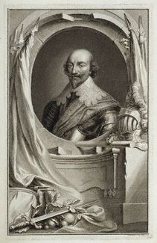

Robert Bertie, 1st Earl of Lindsey
From an engraving by Jacobus Houbraken, after Cornelius Johnson
3
1661 Warrant for money to Earl of Lindsey for pay due to the keepers of Walthamstow Walk, Leyton Walk, Wallwood Woods, Hamfrith Woods . . . .
Similar warrants may be quoted to Robert Bertie, the 3rd Earl in 1668, and to Robert, his eldest son, in 1684. The 3rd Earl, styled in a warrant as Keeper of Waltham Forest, issued in December 1671, is:
Ordered to prevent the keepers from killing deer with guns and restrain them to crossbows and hounds. When deer are killed by accident and become chance deer they are to be taken to the nearest Justice of the Peace and distributed among the poor. No warrants for grants are to be allowed unless signed by the King.
It has been suggested that with the use of the name Royal Lodge there may be a connection between it and The Lodge in Low Layton Walk in which the under-keeper of the Walk lived. There is evidence for the building of this Lodge in 1610, its repair in 1620 and again in 1685, when it is said to be the residence of Thomas Jury, the under-keeper. It seems to me most unlikely that such a menial servant was likely to live in such a large and well filled house. Besides which the Leyton Rate Books for that period show that he was not the occupant. In connection with this situation of this Lodge I make a conjecture that it may have been the ancient part of Gwydr Lodge, Snaresbrook, a central spot in the Walk from which he could have exercised his surveillance.
Reverting to the Manor Rolls we find that Robert Garsett had, out of Court on 7 September 1639, surrendered to Daniel Andrews the messuage called Andrews with barn, sheds, hay-house, coach-house, fish ponds and a meadow of 1½ acres in occupation of Thomas Nevett or assigns. This being reported at the next Court 23 April 1640, the said Daniel Andrews was duly admitted to the property. The new holder has many associations with Leyton which may be found in my monograph on Park House. I have been unable to find anything relative to the above Thomas Nevett.
Daniel Andrews held also other copyholds which lay south of Andrews and we find no further entries on the Rolls until 9 April 1679, when Daniel, in his old age proposing to marry as his second wife a widow, Grace Pearce of London, asked the Court to enter the fact that the copyhold was to be to both of them for the term of their natural lives and then to the survivor of them. The tenant at this time was Thomas Caresley. The Rate Books (which start in 1651) enter him as Mr Henry Kearsley from 1669, then comes Mrs Kearsley in 1673 and then Mr Thomas Kearsley until 1685 where the premises are “empty”. Daniel Andrews died soon after his marriage and his widow surrendered the copyhold to a Mrs Mary Pate, a widow said to be of Little Warley, Essex. Daniel Andrews also held in copyhold valuable property lying to the south and to this also Mrs Pate became owner, and consequently for a number of years the Manor history of both became merged and are recorded in my monograph A History of Park House (1961) a copy of which may be seen in the Reference Department of Leyton Library. There is a gap in the records from January 1687 to 5 March 1704 but an entry of 30 April 1711 recites that on 23 December 1702 Mary Johnson, widow, was admitted to the messuage called Andrews, and now at this present Court comes Samuel Cotton, merchant, with her will dated 29 September 1709 by which she leaves the copyhold to her son-in-law, Samuel Cotton, for life, with remainder to two trustees and their heirs to support the contingent remainder to her daughter Mary, wife of Samuel, for her life and the remainder to her grandson, William Cotton, son of the said Mary and Samuel. In the meantime the tenants of Andrews were 1688 Mr Knot, 1689 Samuel Hanson, esq, 1691 Mrs Burden, 1697 Mr Prickman who left in 1698 with his half yearly rate account of 13s 5½d unpaid. Then in 1699 came the aforementioned Samuel Cotton whose name is as seen on the manor Map of Ruckholt, 1721, which identifies the premises. Mr Cotton continued here for a long time but at Court held 19 February 1732 it was reported that he and a relative, James Cotton, merchants of London, had been adjudged bankrupt and that the Committee for Bankruptcy had given power to two of the assignees to apply to the Manor Court re the:
4
messuage known as Andrews with yard, barns, stables, outhouses, edifices, gardens, orchards, fisheries and appurtenances with a close of meadow of two acres and a piece of land called the slip or passage leading from the messuage to the said close.
The two assignees were admitted to hold the premises during the life of Samuel Cotton, and appointed John Nash (who farmed adjoining land at the time) to hold it as their agent. It was stated that the mother, Mary Cotton, was dead and consequently the son, Samuel Cotton, was under the terms of his grandmother’s will to be considered as heir and the Court admitted him to all the premises. He then instructed the necessary legal proceedings against Thomas Nash to secure the right to the property. This done, he surrendered to Thomas Churchill, pawnbroker of St Botolph, Aldgate, who was duly admitted. By this rather shady legal process it seems that money was made available to the persons to whom the bankrupts were indebted.
5
Of Samuel Cotton himself I find that in 1710 he was chosen to execute the Office of Surveyor of the Highways for the Leytonstone section of the parish. This work he seems to have carried out very ineffectively for a Vestry meeting appointed two of its members to view the work done on the highways there and to report therein. At the next Vestry it was decided:
To nominate or desire Mr Jeremiah Wakelin of Walthamstow to take a view of the work done and to adjust the Surveyor’s accounts.
Mr Cotton personally seems not to blame, however, as he had paid a deputy to perform his tasks. Similarly in 1714 – 15, when chosen as Churchwarden, he did it by deputy, paying one, Robert Snow, who had lately been appointed Parish Beadle for searching after inmates (lodgers) and taking up vagrants at £5 per annum. An entry in the Register of Burials shows:
1706 Robert Smith Mr Cottons Coachman hanged himself
I think it likely that he is the Samuel Cotton buried at Leyton in 1752.
By 1742 Thomas Churchill was dead and his will had left the copyhold to his wife, Prudence, his house then being in the occupation of Robert Surnam, Esq. Owing to several missing Rate Books, one cannot tract other occupants until 1755 when a Dr Clarke is named, the rateable value being then £25. A Mr Dawson appears in 1757 and John Coulthist in 1765. This gentleman was a schoolmaster who used the house as a boarding school for boys which seems to have successfully run for about 19 years. It is likely that he increased accommodation by extensions to the house and by adapting some of the existing stable buildings. The land behind the house proved an adequate and agreeable playground for his juvenile pupils. The only information concerning him that I have discovered is to be found on a tomb stone in the parish churchyard: Sarah his wife died 1765, Sarah, daughter of John and Sarah, died 1774 aged 14 years, and John himself died 9 September, 1784. The death of Coulthist provided a golden opportunity to another schoolmaster, Mr William Emblin, who for a number of years had run a school in Bow in very cramped conditions, to take a lease of Andrews “situated”, as he says in his printed prospectus:
6
in the rural and pleasant village of Leytonstone, in Essex, for many years occupied as an academy by the late Mr Coulthist; distance about 5 miles from Whitechapel Church. It will be superfluous to say more than it is immediately in the Vicinage of that healthy and delightful spot, Epping Forest, well known for the elegant seat and park of the late Earl Tylney.
He goes on to speak of the manner in which he means to discharge his duty as Tutor and Governor of Youth. His curriculum includes Hebrew, Greek, Latin, French, Italian, and German languages with the use of globes, writing, arithmetic both vulgar and decimal navigation, mathematics’ and merchant’s accounts according to the Italian method. Masters are engaged to teach dancing, drawing, music and fencing. Health, morals, and demeanour of his pupils receive his greatest attention while the most lenient methods are pursued in order to promote emulation and improvement. Success seems to come to him in his new venture as may be proved by the fact that a member of his former pupils subscribed to have a large engraving made of their school. The print is said to be scarce now but a fine copy may be seen at Leyton Public Library. The premises are depicted as seen from the High Road. The main building is symmetrical with 4 large windows on either side with a small one over the central doorway, the whole surmounted by an enormous board showing Mr Emblins Academy. The grassed front garden is apparently the master’s private part. To the left of this main building are 2 very plain additions in front of which is a grassed playground where a number of the pupils may be seen indulging in games of the period such as flying kites and bowling hoops. In the extreme left is to be seen a large long building probably a dormitory, and a covered shelter, with open sides. For a number of years Mr Emblin rented a large field lying well behind his premises and extending right down to present Grove Green Road called Draper’s Field, it having been given to the Company by a Mr Park to provide a small company almshouse for impoverished members. I assume that this field would have been used as a sports field.
By the year 1801 the Rate Books give the tenant as Mr Johnes (late Mr Emblin). I have so far been unable to discover if Emblin was dead or had retired from school mastering but the new tenant was here for one year only as the property in 1802 is described as “empty”.
7
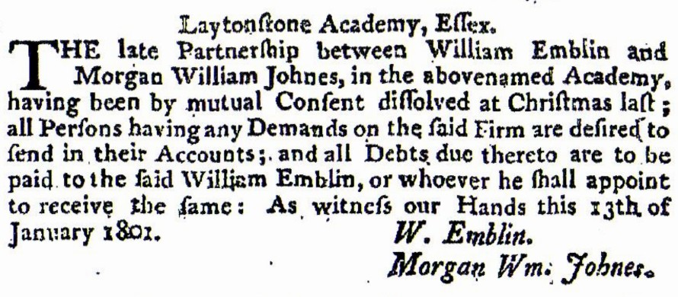
The London Gazette, 13 – 17 January 1801

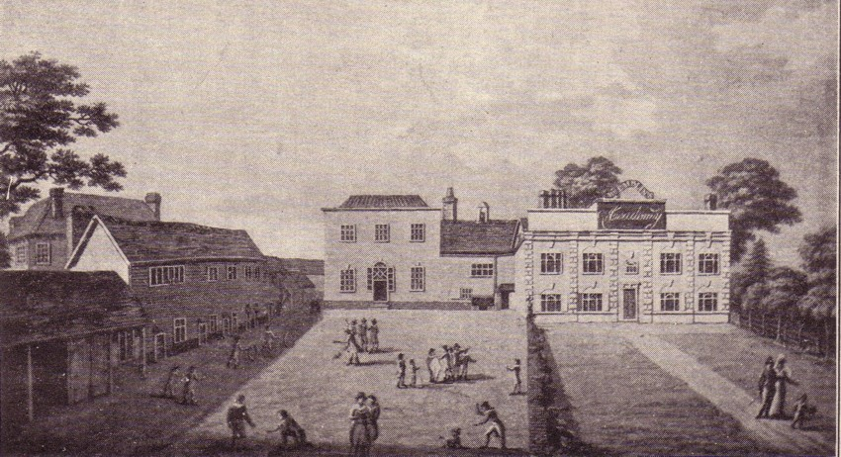
Emblin’s Academy at Laytonstone circa 18oo
8
Then a Mr John Couderoy came and was tenant from 1803 to 1817 with an increase in the rateable assessment from £25 to £32.
Dwelling House Laytonstone – By Messrs Drivers at Garraway’s on Thursday the 30th inst at 12.
A valuable copyhold estate, called Laytonstone Academy, eligibly situate adjoining the turnpike road at Laytonstone in the county of Essex, within 7 miles of London; comprising a very convenient and spacious dwelling house, with detached offices, containing on the ground floor, 2 parlous 20 feet by 18 feet, and 16 x 18, a dining room 33 feet by 15, school room 30 x 36 with kitchen etc. On the chamber floor, 7 good bed chambers with closets etc., and 4 rooms in the attics; together with a good garden, and field behind, containing in the whole about 4 acres of rich land, which at the expiration of the lease will form a most desirable situation for building a villa. The above estate is held of the Manor of Laytonstone, subject to a fine certain upon death or alienator, and is at present in the possession of Mr Condray for an unexpired term of 16 years, from Lady Day next, at a net annual rent of £40, who is bound to keep the premises in complete repair – Printed particulars may be had at the Green Man Laytonstone; Spread Eagle, Woodford; and at Garraway’s; and Messrs Drivers, Land Surveyors, etc. Kent Road.
Reverting to the ownership of the copyhold we find that Prudence Churchill mentioned earlier had died by 1767. In her will she left the estate to her son-in-law Peter Thompson. Who held it until 1806 when he by deed poll, in which he is described as of Dulwich, Major in the Royal Surrey Regiment Militia, made surrender to Hannah, wife of Anthony Barbre. An entry in the Court Roll of 4 April 1822, shows that she
With the consent of her husband who being an alien is unable to join in with the surrender, for love and affection to Clairon, wife of Charles Cuerton of Clapham Common, surrenders to Richard Cuerton, of Whipps Cross, Walthamstow, in trust for Clairon and Charles Cuerton, they to pay to Hannah Barbie an annuity of £80 in quarterly payments for her life.
9
She then set up an entail of the property in favour of the sons of the said Clairon and Charles. That same year Mr Barbie entered into residence and on 3 January 1823, he attended the Vestry meeting to appeal against that increased assessment having being raised to £50. He said the premises had lately been used as a school, and now part of it was totally unoccupied. He kept no carriage or horses and yet was liable under an ancient Act of Parliament to provide a “team” for road maintenance. The Vestry agreed to reduce his assessment to £49 to obviate his liability. The amount of money to be raised totally at this time was extraordinarily high as great unemployment and distress called for so great increase in the Poor Rate and the Church Rate of 3s 6d in the pound owing to a deficit of well over £1100 in consequence of reconstruction work on the parish church.
The mention above by Barbie “late a school” confirms what I had suspected that various people had endeavoured to run the school after Mr Emblin most of them with a lack of success (except John Couderoy who was here for 14 years), Rev Dr Sandby 1818, James Bluck (late Sandby) 1819, Rev W T Hanbury 1820, Mr Hanbury (late Rev Hanbury) 1821, being proof of this. Of these the only one of whom I have been able to gleam any information is that of Hanbury, viz, a death notice in the Times of 10 May 1821:
At Leytonstone, Essex, the Rev William Hanbury MA of New College, Oxford, chaplain to His Majesty’s Palace Court, a gentleman eminently distinguished for his literary attainments amiable character and unaffected piety whose loss will be long deplored by his parents and numerous friends. Aged 24.
Anthony Barbie continued until 1838 when the aforementioned Charles Cuerton came for a very short period. Although the Manor Rolls do not mention it the fact that Barbie’s wife, Hannah, was now dead must be assumed. This is strengthened by an entry of 1842 by which Richard Cuerton is granted licence to let the premises to James Cockrane, a timber merchant of Well Street, East Smithfield, at an annual rent of £50. I find that Richard Cuerton, Esq was one of only 17 persons whose names appear in the Voters List of Freeholders in Walthamstow entitled to vote in the:
Election of Knights of the Shire of Co. Essex in 1830.
He lived in Wood Street, Walthamstow (probably the Clock House) according to an entry in Pigot’s Directory of 1832 – 34.
10
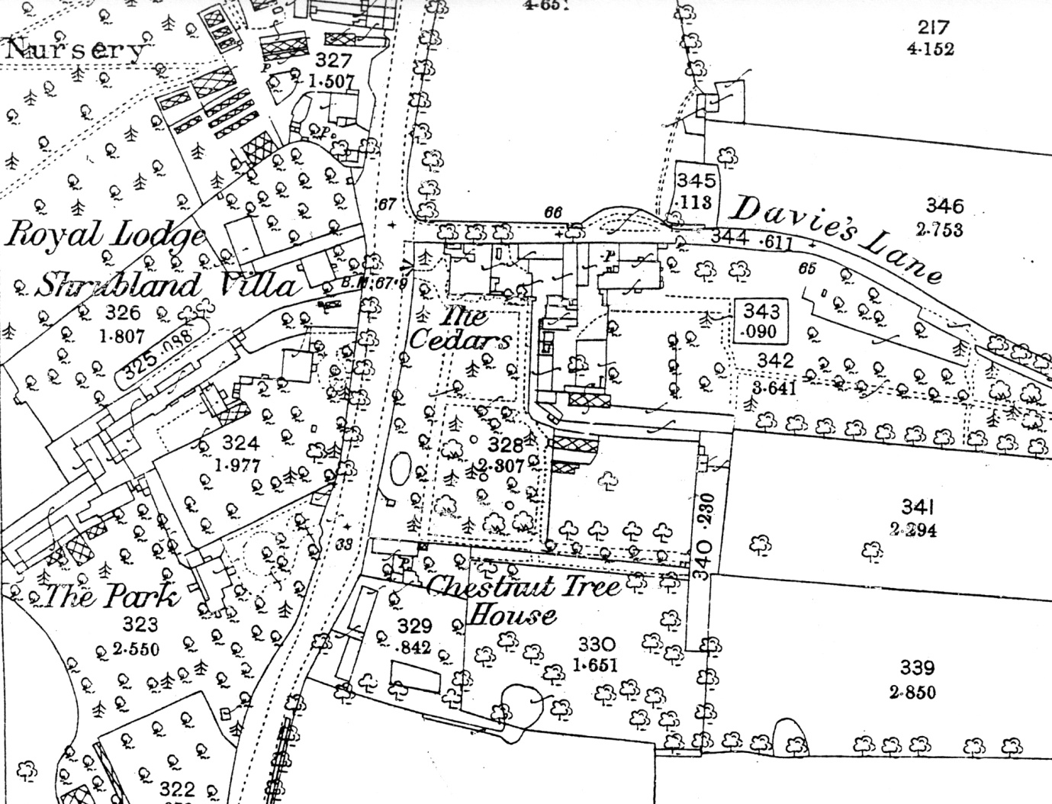
Ordnance Survey Map of 1863
James Cockrane in 1844 had the rateable value of his house reduced. This is the first time that I have found it referred to as the Royal Lodge, this from the local directories. This reduction, I believe, arose owing to the that the grounds had been utilised as a site for the building of a house with garden which some years later was known as Shrublands.

End of Frederick Temple’s monograph

11

There is contemporary account of the fire of 1878 given by the Rev F W Wilkinson in his History of Leyton, which is worth repeating in full, although it repeats the long held view that it really was a royal building, although there is no evidence that Nell Gwynne ever stayed here:
The original house was largely composed of wood, and was burnt down somewhere about twenty years ago. Still certain portions of the original house remain and are incorporated in the present building. The old house was a hunting lodge of Charles II’s., and the house occupied by Nell Gwynne stood opposite side of the road at the corner of Davis Lane (a little of the old brickwork still remains close to the new little houses in the lane) and a subterranean passage evidently led from one house to the other, part of which is still exists, though best part filled with rubbish, as was found on digging down to it a few years ago. The stables, which evidently belonged to the hunting lodge, were only pulled down two or three years ago to make room for the new Midland Station and were extremely old. There are some yews in the garden which probably belonged to it in early times. A couple of beautiful cedars of Lebanon stood in front of the old house opposite until it was pulled down, the stump of one being still in place.

12

Appendix
Yapping dogs and crackling logs
The map reproduced before page 1 of this publication marks the location of Royal Lodge with a thin red circle. On the other side of the High Road the 18th century map shows a road where there still is one now. The present name is Davies Lane. On the old map it was labelled Ld. Lane, presumably an abbreviation of Lord or Lordship Lane. Then as now the road ended at Wanstead Flats. As can be seen from the old map, few roads in Leytonstone go so far back in time. What purpose did it serve ? It is possible the answer may be the building known in the 19th century as the Royal Lodge, of which Frederick Temple was writing.
A hunting lodge would need space for a crowd of visitors on horseback, and the building in question was set a little way back from the High Road. A hunting lodge would need a supply of water for various comforts, and the horses and dogs. The High Road runs along a gravel ridge from which water was later pumped to extensive plant nurseries. Hunting lodges were usually on high ground and some at least were 2 or 3 stories high for a better view. They often had a ‘lawn’, ‘laund’ or ‘plain’ onto which animals could be driven for killing before spectators. The Royal Lodge was on relatively high ground, looking across the High Road down Davies Lane to open Epping Forest land, and on the other side across the valley of the Fillebrook stream to Wallwood. It was burnt down in the 19th century and we do not know what the inside looked like.
Leytonstone was in the manor of Ruckholt, though the manor house was in Leyton and its carriage drive has become Ruckholt Road. Leyton High Road has a mystery, Walnut Tree House, also timber-framed, built about 1600. It was in the manor of Leyton Grange which had its boundary at the Fillebrook stream. There are no records for the construction of Walnut Tree House or its early owners, yet it was for the period an expensive and prestigious building. One explanation might be that it was a hunting lodge. A number of large and striking fireplaces survive, excellent for aristocratic and royal huntsmen to get warm after their healthy outdoor recreation. In the middle of the 13th century the Abbey of Stratford Langthorne which owned the church and Grange manor of Leyton was allowed to take Wallwood out of the Epping Forest jurisdiction, to make a visible boundary, and to have hunting rights within it. In the 17th century Wallwood belonged to the King. Queen Elizabeth I, James I and Charles II all visited Ruckholt House. From there they could have reached both the Royal Lodge and Walnut Tree House in one day’s sport.
My idea that the two buildings were hunting lodges is pure speculation, but it does offer a possible solution to two mysteries.
David Boote

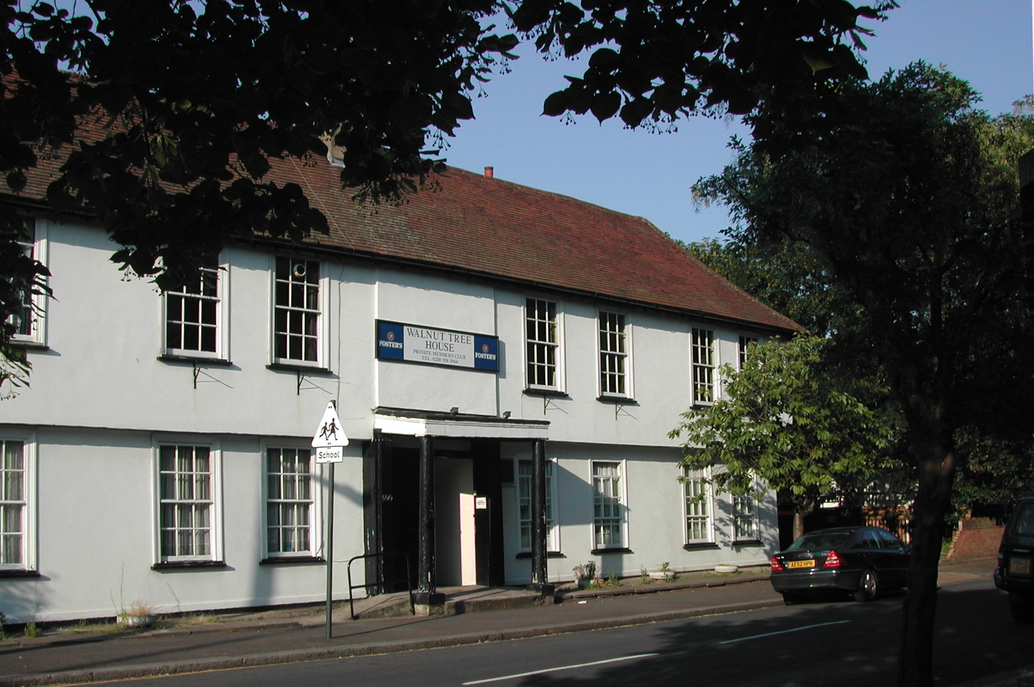

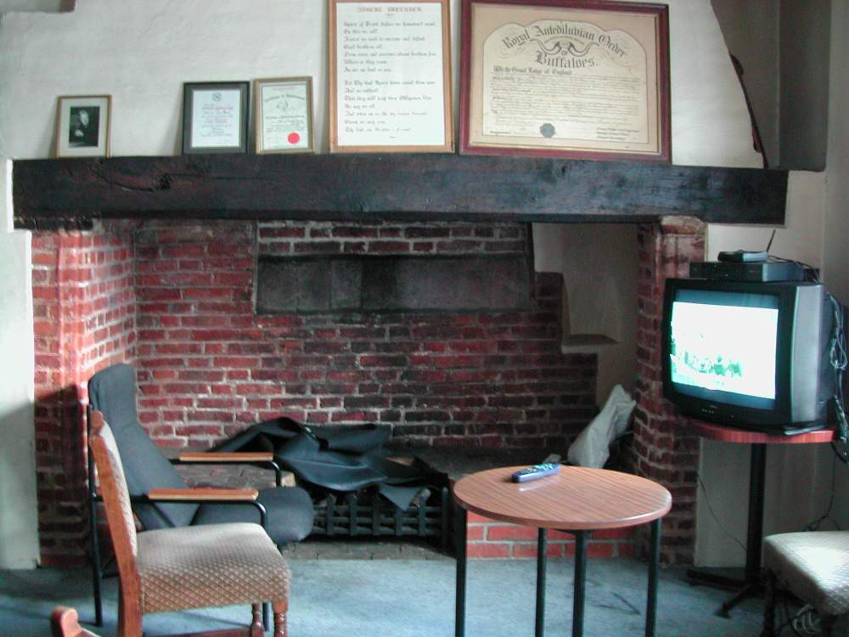

William George Hammock, baptised Stepney 13 June 1825, and died in West Ham, 1912. A retired marine engineer he was churchwarden of St John’s Parish Church, Leytonstone at the time of publication of Leytonstone and its History, Batten & Davies, Clapham, 1904. Copies now available on CD from the L&LHS.
Now Davies Lane.
Henry Clayton, born in Wellington, Shropshire, circa 1814, and had been resident in Leytonstone since 1855 but he only took over occupancy of the Royal Lodge in November 1873. He obtained outright ownership in 1876. Henry and his wife Matilda had four children, Harry, Nancy and Julia and Kathleen. He was overseer in 1864.
William Stone died September 1607. Had been knighted in 1604 and became an Alderman for the Farringdon Without Ward in 1605 and Master of the Clothworkers Company in 1606.
Robert Bertie (17 December 1582 – 24 October 1642), 1st Earl of Lindsey. Mortally wounded at Edgehill he died the following day of his injuries.
Montagu Bertie (1608 – 25 July 1666) 2nd Earl of Lindsey.
The usually reliable Mary Savell makes a curious mistake in her otherwise excellent article on the Royal Lodge written for the Walthamstow & Leyton Guardian and printed in 1965, confusing the Earls of Lindsey with the Lords of Lindsay.
There was a Thomas Nevett, a member of the Goldsmith Company who died c1655.
Daniel Andrews (or Andrewes) was Master of the Haberdashers Company in 1661-2 and 1678-9, and Alderman of Cordwainers Ward in 1653. He was also as an official with the East India Company and the Levant Company. He died 16 January 1682.
Also referred to as Grace Pearse.
Mary Savell is of the opinion that Mary Pate married George Hockenhall of Park House at around this time. Royal Lodge, Leyton Past #8, November 1978
This is now held in the Local Studies Library, Vestry House Museum.
Far from being a gap in the records, it would appear that George Hockenhall of Park House was rated for both properties. Hockenhall was also most certainly married to Mary Pate as it is known that his wife was called Mary. They went on to have five children, George baptised 8 May 1687, Margaret baptised 21 January 1689, Elizabeth baptised 4 March 1690, and buried 26 September 1691, Wynne baptised 27 January 1693, and buried 29 May 1700, and finally a son, Pate baptised 13 November 1695. The latter supporting the supposition that Mary Hockenhall nee Pate. George Hockenhall was Overseer in 1689, Churchwarden in the years 1694 and 1695 and surveyor for the Highways of Leytonstone for 1701.
Samuel Cotton 1661-1746.
Temple footnote: This gentleman subscribed £3 4s 6d (3 guineas) to a local collection on behalf of Irish Protestants who fled to England in 1689.
Samuel Cotton died 20 February 1752.
Sarah Coulthist was baptised 12 July 1763 and buried 15 January 1778 (not 1774).
John Coulthist married Sarah Hall 1 July 1761 at St Mary’s Whitechapel. She died and was buried 16 January 1765.
William Emblin must have been a close friend of Leyton’s vicar, the Rev Thomas Keightley (1754-1797), as he was a witness to Rev Keightley’s wedding to Sarah Brown, a widow, 9 September 1788.
In the 1790’s Mr Emblin's Academy at Leytonstone used to advertise that, "New pupils will be met at Raymond's Snuff Shop, 125 Cheapside, and at the Saracen's Head Inn, Aldgate".
From the Prospectus dated 1785. Quoted in full by Mary Savell in Royal Lodge, Leyton Past #8, November 1978, also published in the Walthamstow & Leyton Guardian in 1965.
Temple Footnote: 18 inches by 12 inches, by J Merigot after T Atkins, Jan. 1 1880. Ed. David Boote was able to photograph the print which had been located in a room above Leyton Library.
This was Dyers Hall and not to be confused with the current Draper’s Field in Leyton High Road.
He died in 1802. (Victoria County History – Leyton Section – page 65).
This advertisement, discovered after Frederick Temple had completed his monograph, clearly indicates that for the last year of William Emblin’s occupation he had gone into partnership with Morgan Johnes. We can only presume that ill health forced William Emblin to dissolve the partnership.
This is quite a rare print for in 1937 Lord Wakefield paid £10 for a copy (Noted by Temple from information received from Charles Hall Crouch)..
John Coudroy married Ann Groves in 1800 at St Pancras. They had four children born in Leytonstone and like their mother all were given Christian names beginning with “A”. Alfred Baynard John born 1 October 1802, and a second son Adolphus James born 18 December 1804. Both boys being baptised together on 6 January 1805. The younger one died two years later and was buried 2 October 1808. Their only daughter, Amelia Sophie was baptised 2 October 1808 and a final son, Adolphus Lionel baptised 10 February 1811. Coudroy had been a professor at a Royal Military College in France. An advertisement for 1812 showed the boarding fees were 30 guineas a year.
Taken from a Newspaper cutting held by the Vestry House Museum, dated c1806.
Hannah Barbre (or Barbie) and her husband Anthony, born circa 1754, were shown as occupying the “Royal Lodge” in the 1831 census. Anthony had died and was buried 2 August 1831 at St Luke’s, Old Street, Hannah retained sole ownership until Lady Day 1836.
Clairon Barbre of Stoke Newington (only daughter of Anthony and Hannah Barbre) married Charles Cuertor, a gentleman, 24 January 1807 in St Mary’s, Leyton. Witnesses to their marriage were Anthony Barbre and Julia Hannah Barbre. Charles and Clairon had two daughters born in Leytonstone, Gertrude born 14 March 1823 and Clara Matilda born 3 February 1826. They retained ownership of the “Royal Lodge” from Lady Day 1832 to Michelmas 1838.
Under Bluck or Buck the school had been completely renovated according to an advertisement of 1819. Yet despite transferring his business from the Bath House Academy in Muswell Hill to Leytonstone Bluck was unable to make a success of it.
William Tomisman Hanbury, matriculated New College, Oxford 14 October 1813, aged 17; clerk 1813-17, BA 1817, MA 1820 (Oxford University Alumni 1500-1886 pp 598).
Joseph Hanbury. Index of Leyton Names, held by the Vestry House Museum).
This is inaccurate as Anthony Barbre had died in 1831. Charles Cuertor occupied the “Royal Lodge” until Lady Day 1839. The new occupier was a Scot, John Mouat or Mowatt, a wine merchant, along with his wife Margaret and their five children. They remained there until February 1842 when it was taken over by sisters, Mary and Elizabeth Miller, who retained part of the estate.
James Cockrane, Cochran or Cockram had occupied the Royal Lodge including the house, stabling and part of the garden in October 1842. This reduction in the rateable value confirms the splitting of the estate. From 1847 to October 1853 the Royal Lodge was occupied by Charles James, a wine merchant from Hackney (Post Office Directory of 1848). He was followed by William Martin who is listed in the Post Office Directory of 1855.
A History of Leyton, Rev F W Wilkinson, Privately Printed, Leytonstone, 1897 pp 76.

